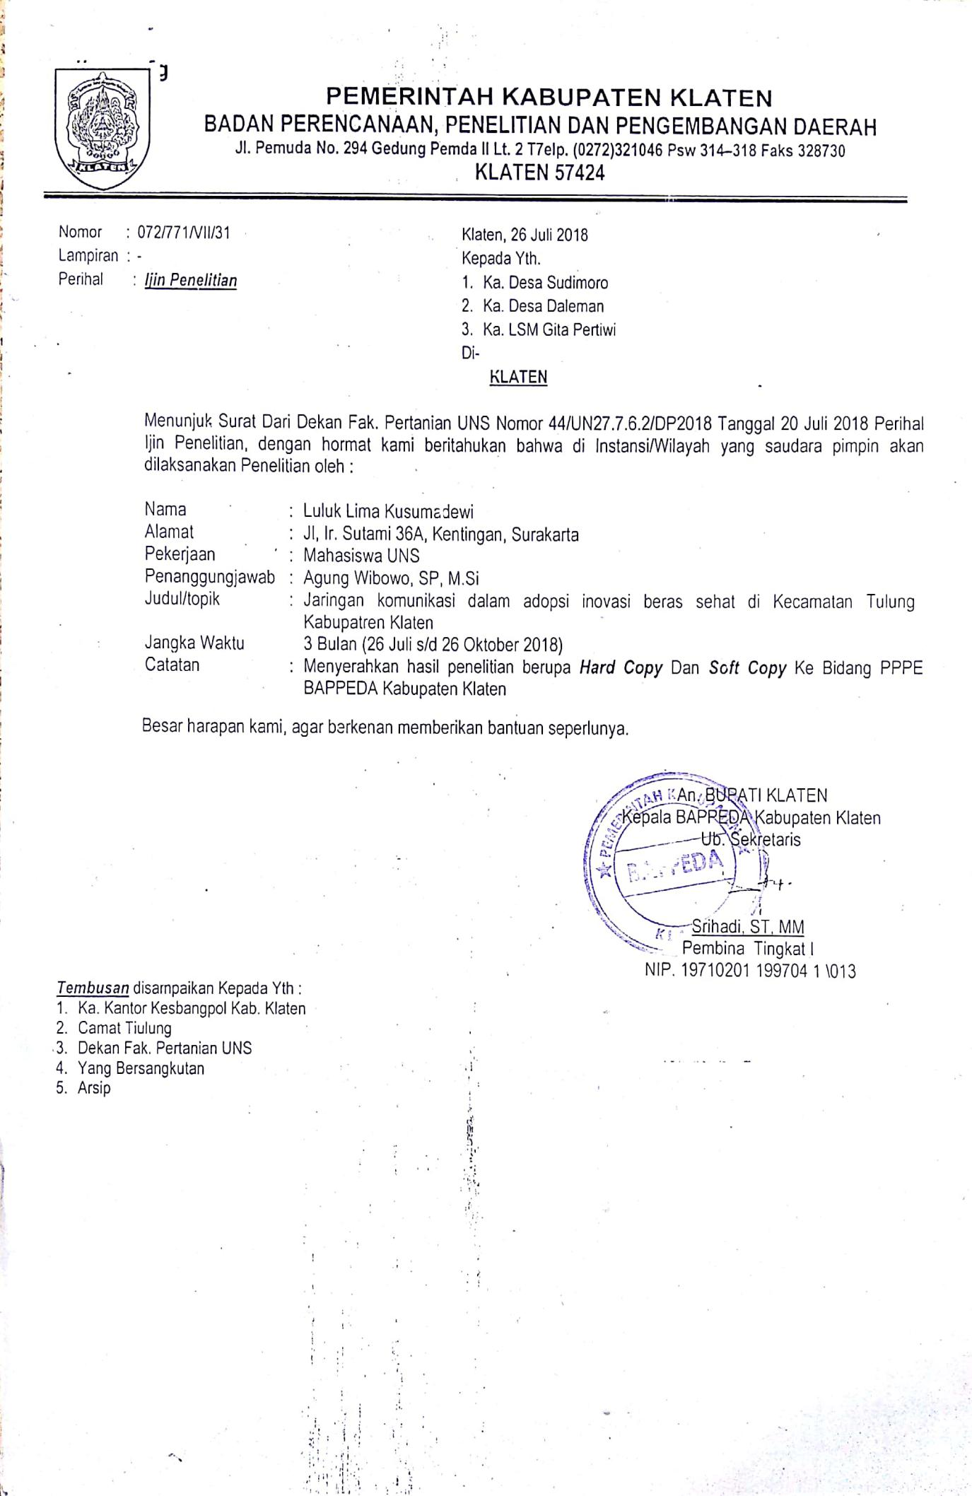
LAMPIRAN 8. SURAT IJIN PENELITIAN

