LAMPIRAN 5. HASIL UJI DESA DALEMAN
HASIL UJI DESA DALEMAN
- UJI SENTRALITAS TINGKATAN
No. | Aktor | Outdegree | Indegree | nOutdegree | nIndegree
1 | A | 17,000 | 17,000 | 0,109 | 0,109
2 | B | 7,000 | 3,000 | 0,045 | 0,019
3 | C | 6,000 | 5,000 | 0,038 | 0,032
4 | D | 6,000 | 2,000 | 0,038 | 0,013
5 | E | 12,000 | 8,000 | 0,077 | 0,051
6 | F | 6,000 | 4,000 | 0,038 | 0,026
7 | G | 3,000 | 2,000 | 0,019 | 0,013
8 | H | 31,000 | 43,000 | 0,199 | 0,276
9 | I | 6,000 | 3,000 | 0,038 | 0,019
10 | J | 10,000 | 8,000 | 0,064 | 0,051
11 | K | 5,000 | 3,000 | 0,032 | 0,019
12 | L | 18,000 | 7,000 | 0,115 | 0,045
13 | M | 5,000 | 2,000 | 0,032 | 0,013
14 | N | 5,000 | 2,000 | 0,032 | 0,013
15 | O | 6,000 | 4,000 | 0,038 | 0,026
16 | P | 4,000 | 2,000 | 0,026 | 0,013
17 | Q | 6,000 | 3,000 | 0,038 | 0,019
18 | R | 6,000 | 2,000 | 0,038 | 0,013
19 | S | 5,000 | 2,000 | 0,032 | 0,013
20 | T | 5,000 | 2,000 | 0,032 | 0,013
21 | U | 0,000 | 8,000 | 0,000 | 0,051
22 | V | 0,000 | 4,000 | 0,000 | 0,026
23 | W | 0,000 | 30,000 | 0,000 | 0,192
24 | X | 1,000 | 4,000 | 0,006 | 0,026
25 | Y | 1,000 | 1,000 | 0,006 | 0,006
26 | Z | 1,000 | 1,000 | 0,006 | 0,006
27 | Aa | 1,000 | 1,000 | 0,006 | 0,006
22 rows, 4 columns, 1 levels.

Graph Centralization -- as proportion, not percentage
1 2
Out-C In-Ce
entra ntral
lizat izati
ion on
----- -----
1 0.0238 0.0862
1 rows, 2 columns, 1 levels.
--------------------------------------
Running time: 00:00:01 seconds.
Output generated: 02 Sep 18 13:10:10
UCINET 6.661 Copyright (c) 1992-2017 Analytic Technologies
- UJI SENTRALITAS KEDEKATAN
Input network dataset : Matrik Full Daleman
Output measures : Matrik Full Daleman-Clo
(Freeman) Set undefined distances to : Max observed distance plus
1
(Freeman) Output options : Divide totals into N-1 (Freeman normalization)
(Valente-Forman) Handle undefined distances : Set reverse distance to zero
(Valente-Forman) Output options : Divide averages by
diameter
(Reciprocal) Handle undefined distances : Set reciprocal distance to
zero
(Reciprocal) Output options : Averages
No. | Aktor | OutCloseness | InCloseness | OutVal  Closeness | InVal  Closeness | OutReciprocal  Closeness | InReciprocal  Closeness
1 | A | 0,650 | 0,371 | 0,980 | 0,843 | 0,731 | 0,481
2 | B | 0,406 | 0,338 | 0,946 | 0,833 | 0,449 | 0,388
3 | C | 0,413 | 0,289 | 0,947 | 0,815 | 0,468 | 0,353
4 | D | 0,419 | 0,338 | 0,949 | 0,833 | 0,474 | 0,385
5 | E | 0,456 | 0,302 | 0,956 | 0,821 | 0,558 | 0,375
6 | F | 0,317 | 0,295 | 0,920 | 0,818 | 0,359 | 0,349
7 | G | 0,252 | 0,382 | 0,890 | 0,846 | 0,310 | 0,442
8 | H | 0,684 | 0,491 | 0,983 | 0,868 | 0,821 | 0,708
9 | I | 0,433 | 0,351 | 0,952 | 0,838 | 0,513 | 0,418
10 | J | 0,520 | 0,433 | 0,966 | 0,858 | 0,590 | 0,532
11 | K | 0,426 | 0,351 | 0,950 | 0,838 | 0,494 | 0,418
12 | L | 0,634 | 0,406 | 0,979 | 0,852 | 0,712 | 0,497
13 | M | 0,413 | 0,347 | 0,947 | 0,836 | 0,455 | 0,399
14 | N | 0,413 | 0,347 | 0,947 | 0,836 | 0,455 | 0,399
15 | O | 0,481 | 0,351 | 0,960 | 0,838 | 0,526 | 0,418
16 | P | 0,413 | 0,347 | 0,947 | 0,836 | 0,455 | 0,399
17 | Q | 0,419 | 0,351 | 0,949 | 0,838 | 0,474 | 0,418
18 | R | 0,419 | 0,347 | 0,949 | 0,836 | 0,474 | 0,399
19 | S | 0,413 | 0,347 | 0,947 | 0,836 | 0,455 | 0,399
20 | T | 0,406 | 0,283 | 0,946 | 0,812 | 0,449 | 0,314
21 | U | 0,167 | 0,481 | 0,000 | 0,897 | 0,000 | 0,590
22 | V | 0,167 | 0,433 | 0,000 | 0,889 | 0,000 | 0,516
23 | W | 0,167 | 0,565 | 0,000 | 0,909 | 0,000 | 0,731
24 | X | 0,317 | 0,356 | 0,920 | 0,839 | 0,359 | 0,423
25 | Y | 0,413 | 0,347 | 0,947 | 0,836 | 0,455 | 0,399
26 | Z | 0,413 | 0,347 | 0,947 | 0,836 | 0,455 | 0,399
27 | Aa | 0,413 | 0,347 | 0,947 | 0,836 | 0,455 | 0,399
27 rows, 6 columns, 1 levels.
--------------------------------------
Running time: 00:00:01 seconds.
Output generated: 02 Sep 18 09:12:43
UCINET 6.661 Copyright (c) 1992-2017 Analytic Technologies
- SENTRALITAS KEPERANTARAAN
No. Aktor | Kode Aktor | Betweenness | nBetweenness
8 | H | 386,700 | 59,492
1 | A | 180,200 | 27,723
12 | L | 116,500 | 17,923
5 | E | 75,000 | 11,538
10 | J | 41,700 | 6,415
24 | X | 30,500 | 4,692
7 | G | 20,000 | 3,077
4 | D | 9,500 | 1,462
3 | C | 1,500 | 0,231
9 | I | 0,200 | 0,031
11 | K | 0,200 | 0,031
2 | B | 0,000 | 0,000
13 | M | 0,000 | 0,000
14 | N | 0,000 | 0,000
15 | O | 0,000 | 0,000
16 | P | 0,000 | 0,000
17 | Q | 0,000 | 0,000
6 | F | 0,000 | 0,000
19 | S | 0,000 | 0,000
20 | T | 0,000 | 0,000
21 | U | 0,000 | 0,000
22 | V | 0,000 | 0,000
23 | W | 0,000 | 0,000
18 | R | 0,000 | 0,000
25 | Y | 0,000 | 0,000
26 | Z | 0,000 | 0,000
27 | Aa | 0,000 | 0,000
DESCRIPTIVE STATISTICS FOR EACH MEASURE
 |  | Betweenness | nBetweenness
1 | Mean | 31,926 | 4,912
2 | Std. Dev | 80,932 | 12,451
3 | Sum | 862,000 | 132,615
4 | Variance | 6549,917 | 155,028
5 | Minimum | 0,000 | 0,000
6 | Maximum | 386,700 | 59,492
Network Centralization Index = 56.68%
Output actor-by-centrality measure matrix saved as dataset matrik full daleman-bet
----------------------------------------
Running time: 00:00:01
Output generated: 02 Sep 18 09:15:02
UCINET 6.661 Copyright (c) 1992-2017 Analytic Technologies
- KLIK
Minimum Set Size : 3
Input dataset : Matrik Full Daleman

21 cliques found.
1: H I J L W
2: A H J L W
3: H K L W
4: H L O W
5: H L Q W
6: H R W
7: G H J W
8: H I J U
9: A H J U
10: H K U
11: A H J L V
12: A B L W
13: A C D W
14: A C T
15: A C U
16: A D L W
17: A D E W
18: A E J U
19: A E J W
20: A E F
21: A E X

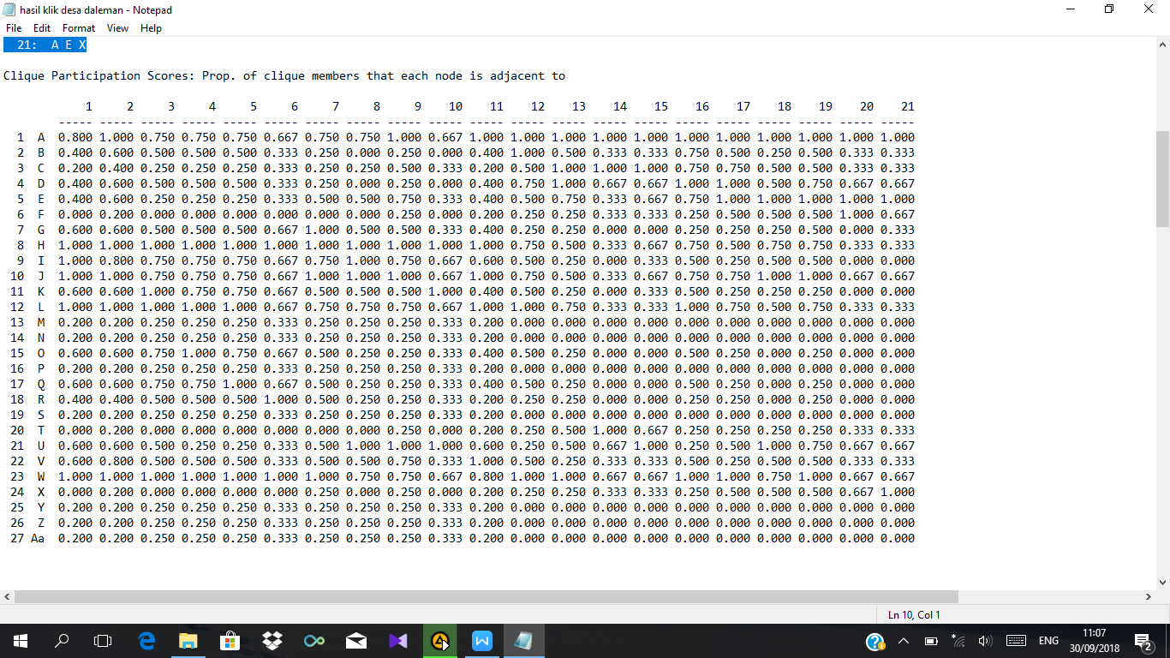

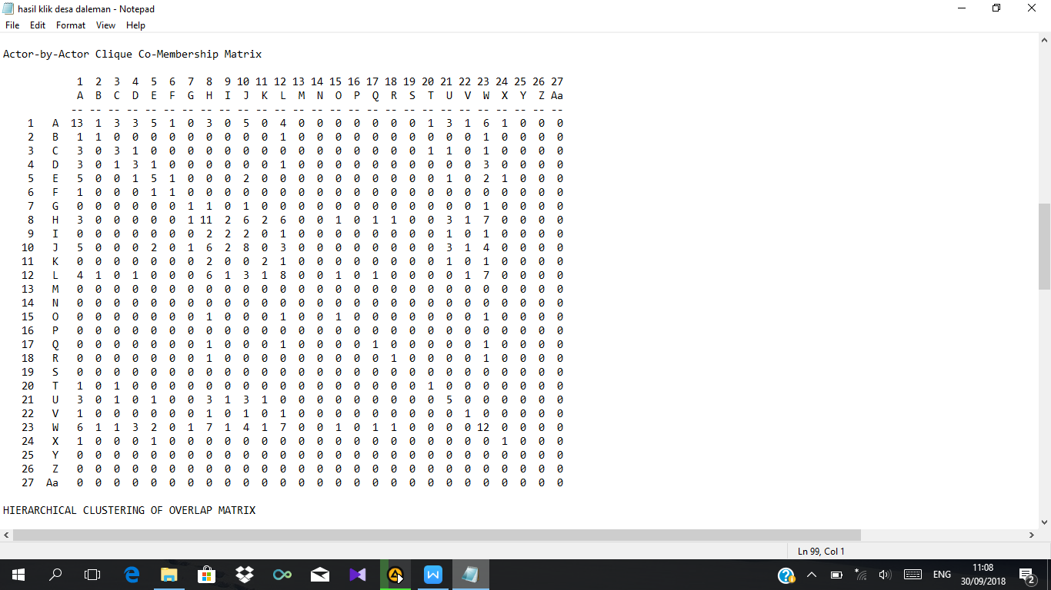

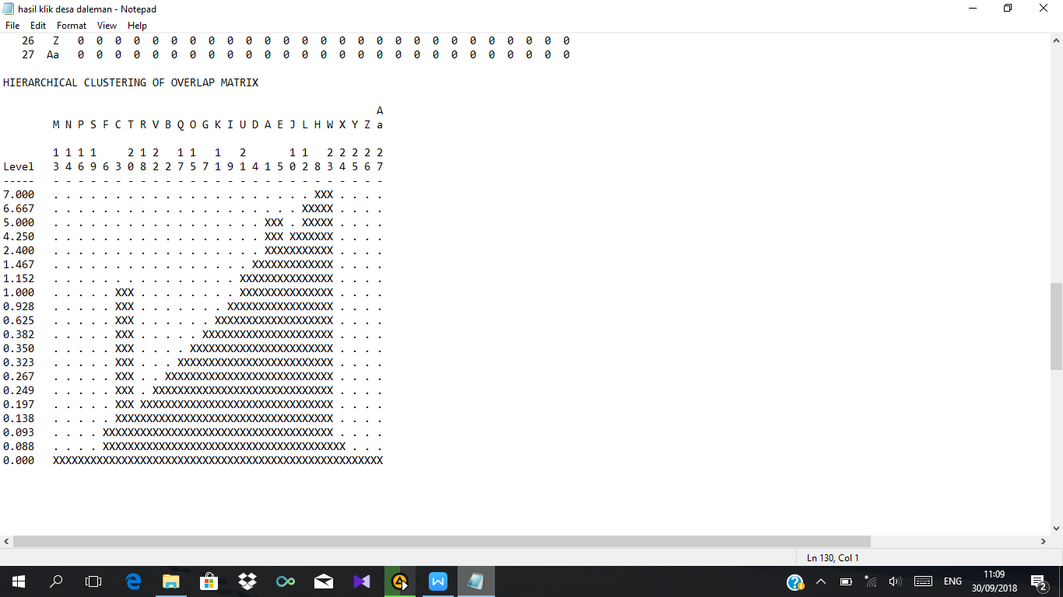
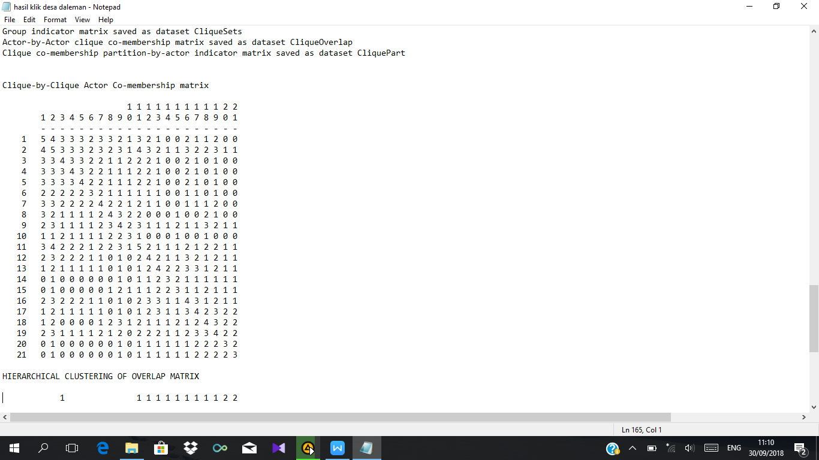

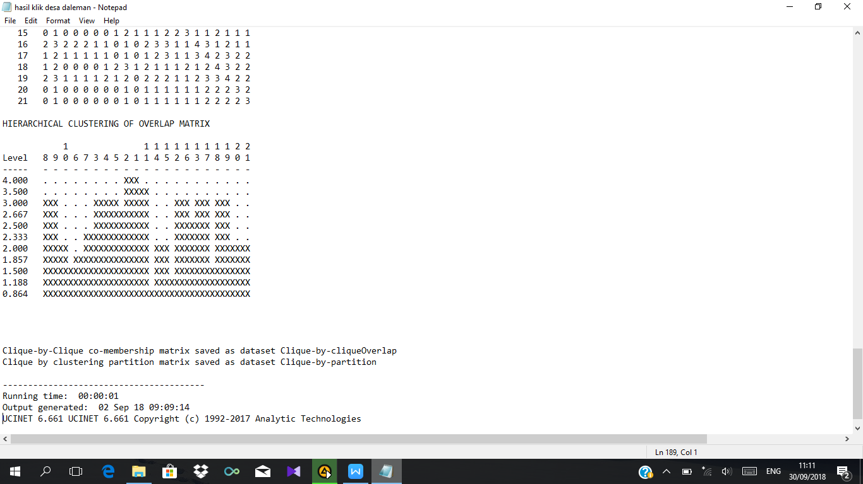

Clique-by-Clique co-membership matrix saved as dataset Clique-by-cliqueOverlap
Clique by clustering partition matrix saved as dataset Clique-by-partition

----------------------------------------
Running time: 00:00:01
Output generated: 02 Sep 18 09:09:14
UCINET 6.661 UCINET 6.661 Copyright (c) 1992-2017 Analytic Technologies

- STRUKTUR JARINGAN KOMUNIKASI (KEPADATAN (DENSITY) DAN DIAMETER)
Whole Network Measures
No. | Analisis | Hasil
1 | Avg Degree | 3,296
2 | Indeg H-Index | 5
3 | Deg Centralization | 0,611
4 | Out-Central | 0,587
5 | In-Central | 0,467
6 | Density | 0,127
7 | Components | 4
8 | Component Ratio | 0,115
9 | Connectedness | 0,889
10 | Fragmentation | 0,111
11 | Closure | 0,258
12 | Avg Distance | 2,381
13 | SD Distance | 0,935
14 | Diameter | 5
15 | Wiener Index | 1486
16 | Dependency Sum | 862
17 | Breadth | 0,558
18 | Compactness | 0,442
19 | Small Worldness | 1,617
20 | Mutuals | 0,066
21 | Asymmetrics | 0,123
22 | Nulls | 0,812
23 | Arc Reciprocity | 0,517
24 | Dyad Reciprocity | 0,348
24 rows, 1 columns, 1 levels.

For symmetric matrices, Centralization is Freeman's degree centralization.
For non-symmetric matrices, Centralization is indegree centralization.

--------------------------------------
Running time: 00:00:01 seconds.
Output generated: 02 Sep 18 09:31:24
UCINET 6.661 Copyright (c) 1992-2017 Analytic Technologies

