LAMPIRAN 4. HASIL UJI DESA SUDIMORO
HASIL UJI DESA SUDIMORO
- UJI SENTRALITAS TINGKATAN

No. | Aktor | Outdegree | Indegree | nOutdegree | nIndegree
1 | A | 3,000 | 1,000 | 0,036 | 0,012
2 | B | 3,000 | 0,000 | 0,036 | 0,000
3 | C | 3,000 | 1,000 | 0,036 | 0,012
4 | D | 5,000 | 0,000 | 0,060 | 0,000
5 | E | 8,000 | 4,000 | 0,095 | 0,048
6 | F | 5,000 | 4,000 | 0,060 | 0,048
7 | G | 2,000 | 1,000 | 0,024 | 0,012
8 | H | 4,000 | 2,000 | 0,048 | 0,024
9 | I | 4,000 | 2,000 | 0,048 | 0,024
10 | J | 4,000 | 1,000 | 0,048 | 0,012
11 | K | 3,000 | 4,000 | 0,036 | 0,048
12 | L | 11,000 | 7,000 | 0,131 | 0,083
13 | M | 4,000 | 1,000 | 0,048 | 0,012
14 | N | 2,000 | 1,000 | 0,024 | 0,012
15 | O | 7,000 | 1,000 | 0,083 | 0,012
16 | P | 2,000 | 1,000 | 0,024 | 0,012
17 | Q | 1,000 | 1,000 | 0,012 | 0,012
18 | R | 1,000 | 1,000 | 0,012 | 0,012
19 | S | 1,000 | 1,000 | 0,012 | 0,012
20 | T | 1,000 | 0,000 | 0,012 | 0,000
21 | U | 0,000 | 31,000 | 0,000 | 0,369
22 | V | 0,000 | 9,000 | 0,000 | 0,107
22 rows, 4 columns, 1 levels.

Graph Centralization -- as proportion, not percentage
1 2
Out-C In-Ce
entra ntral
lizat izati
ion on
----- -----
1 0.0238 0.0862

1 rows, 2 columns, 1 levels.
--------------------------------------
Running time: 00:00:01 seconds.
Output generated: 02 Sep 18 13:10:10
UCINET 6.661 Copyright (c) 1992-2017 Analytic Technologies
- UJI SENTRALITAS KEDEKATAN
Input network dataset : Matrik Full Sudimoro
Output measures : Matrik Full Sudimoro-Clo
(Freeman) Set undefined distances to : Max observed distance plus
1
(Freeman) Output options : Divide totals into N-1 (Freeman normalization)
(Valente-Forman) Handle undefined distances : Set reverse distance to zero
(Valente-Forman) Output options : Divide averages by
diameter
(Reciprocal) Handle undefined distances : Set reciprocal distance to
zero
(Reciprocal) Output options : Averages
No | Aktor | OutCloseness | InCloseness | OutVal  Closeness | InVal  Closeness | OutReciprocal Closeness | InReciprocal Closeness
1 | A | 0,239 | 0,214 | 0,413 | 0,539 | 0,278 | 0,200
2 | B | 0,181 | 0,167 | 0,095 | 0,000 | 0,095 | 0,000
3 | C | 0,181 | 0,174 | 0,095 | 0,048 | 0,095 | 0,048
4 | D | 0,189 | 0,167 | 0,143 | 0,000 | 0,143 | 0,000
5 | E | 0,247 | 0,276 | 0,420 | 0,587 | 0,349 | 0,357
6 | F | 0,244 | 0,276 | 0,418 | 0,587 | 0,325 | 0,357
7 | G | 0,174 | 0,219 | 0,048 | 0,580 | 0,048 | 0,212
8 | H | 0,228 | 0,244 | 0,405 | 0,565 | 0,250 | 0,270
9 | I | 0,231 | 0,266 | 0,407 | 0,580 | 0,258 | 0,302
10 | J | 0,236 | 0,239 | 0,411 | 0,561 | 0,290 | 0,238
11 | K | 0,236 | 0,296 | 0,411 | 0,597 | 0,270 | 0,397
12 | L | 0,375 | 0,219 | 0,777 | 0,286 | 0,556 | 0,286
13 | M | 0,300 | 0,208 | 0,747 | 0,275 | 0,384 | 0,167
14 | N | 0,174 | 0,206 | 0,048 | 0,310 | 0,048 | 0,151
15 | O | 0,313 | 0,208 | 0,753 | 0,275 | 0,424 | 0,167
16 | P | 0,174 | 0,206 | 0,048 | 0,310 | 0,048 | 0,151
17 | Q | 0,292 | 0,208 | 0,742 | 0,275 | 0,337 | 0,167
18 | R | 0,292 | 0,208 | 0,742 | 0,275 | 0,337 | 0,167
19 | S | 0,292 | 0,208 | 0,742 | 0,275 | 0,337 | 0,167
20 | T | 0,309 | 0,167 | 0,788 | 0,000 | 0,360 | 0,000
21 | U | 0,167 | 0,656 | 0,000 | 0,939 | 0,000 | 0,810
22 | V | 0,167 | 0,429 | 0,000 | 0,792 | 0,000 | 0,619
22 rows, 6 columns, 1 levels.
--------------------------------------
Running time: 00:00:01 seconds.
Output generated: 02 Sep 18 13:10:46
UCINET 6.661 Copyright (c) 1992-2017 Analytic Technologies

- SENTRALITAS KEPERANTARAAN
No. Aktor | Kode Aktor | Betweenness | nBetweenness
12 | L | 92,000 | 21,905
11 | K | 51,000 | 12,143
5 | E | 34,000 | 8,095
6 | F | 27,000 | 6,429
10 | J | 13,000 | 3,095
8 | H | 12,667 | 3,016
15 | O | 12,000 | 2,857
1 | A | 6,000 | 1,429
9 | I | 0,333 | 0,079
3 | C | 0,000 | 0,000
2 | B | 0,000 | 0,000
7 | G | 0,000 | 0,000
13 | M | 0,000 | 0,000
14 | N | 0,000 | 0,000
4 | D | 0,000 | 0,000
16 | P | 0,000 | 0,000
17 | Q | 0,000 | 0,000
18 | R | 0,000 | 0,000
19 | S | 0,000 | 0,000
20 | T | 0,000 | 0,000
21 | U | 0,000 | 0,000
22 | V | 0,000 | 0,000

DESCRIPTIVE STATISTICS FOR EACH MEASURE
 |  | Betweenness | nBetweenness
1 | Mean | 11,273 | 2,684
2 | Std. Dev | 22,016 | 5,242
3 | Sum | 248,000 | 59,048
4 | Variance | 484,724 | 27,479
5 | Minimum | 0,000 | 0,000
6 | Maximum | 92,000 | 21,905
Network Centralization Index = 20.14%
Output actor-by-centrality measure matrix saved as dataset matrik full sudimoro-bet
----------------------------------------
Running time: 00:00:01
Output generated: 02 Sep 18 13:11:22
UCINET 6.661 Copyright (c) 1992-2017 Analytic Technologies
- KLIK
Minimum Set Size : 3
Input dataset : Matrik Full Sudimoro

17 cliques found.
1: E F I U
2: E J U
3: C D U
4: G J U
5: F H U
6: L M U
7: L O U
8: N O U
9: O P U
10: E F I K
11: A E F
12: A F H
13: E J V
14: E F V
15: L M V
16: C D V
17: F H V
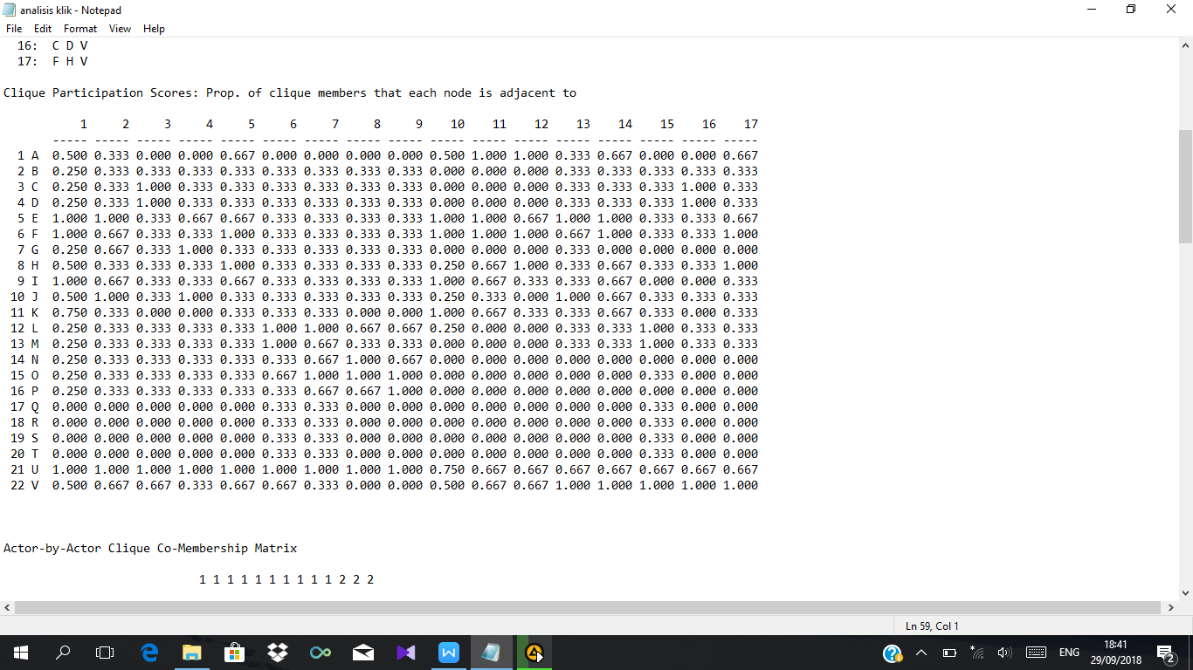
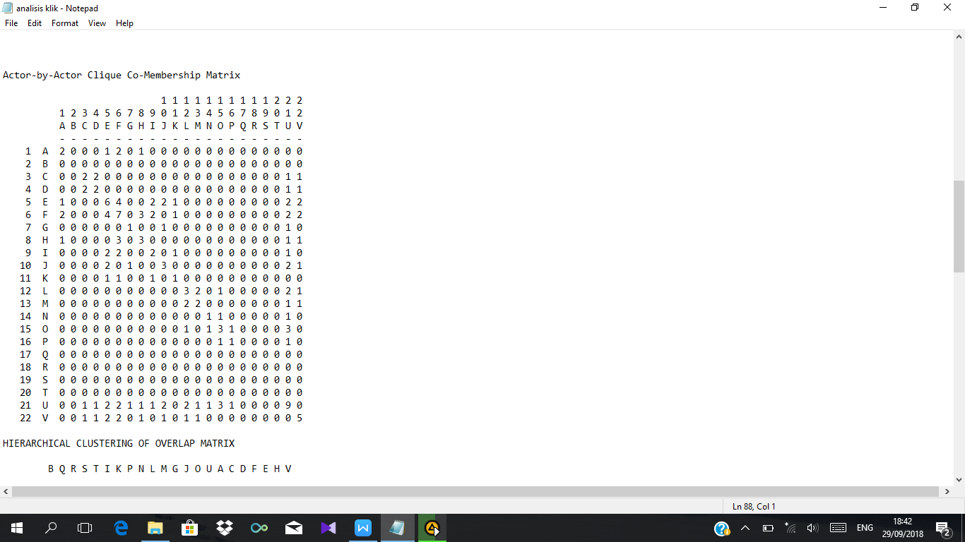
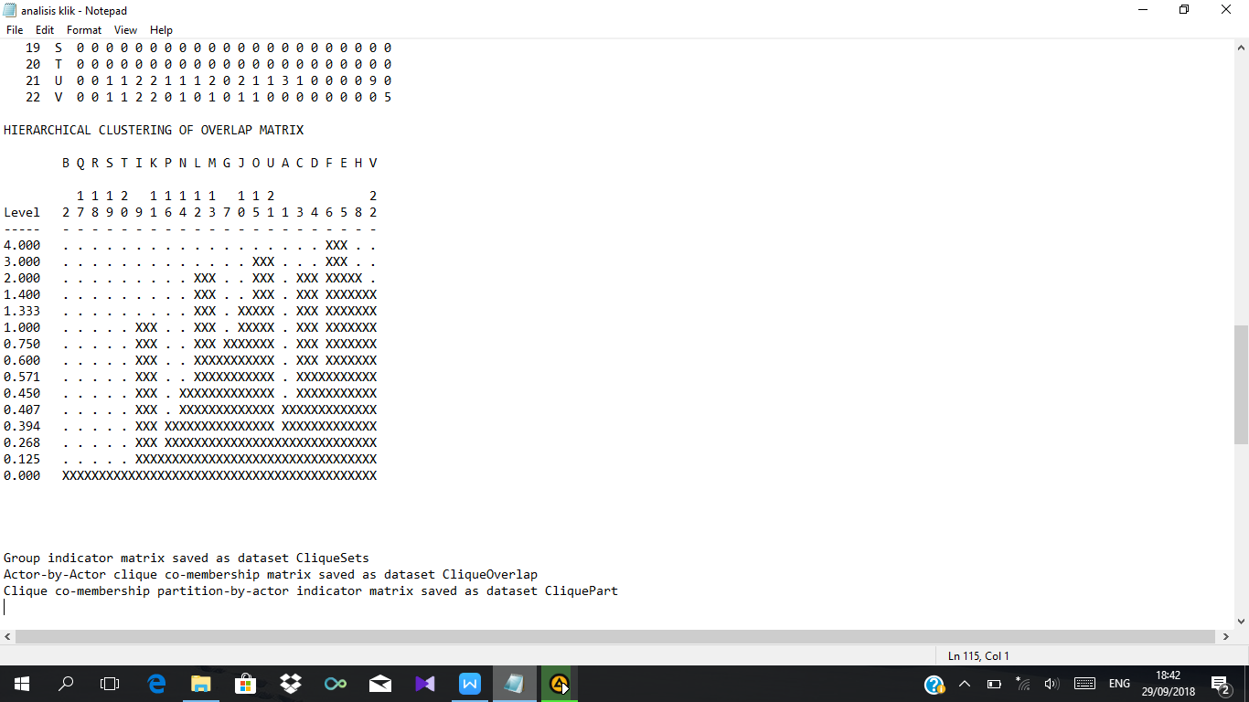
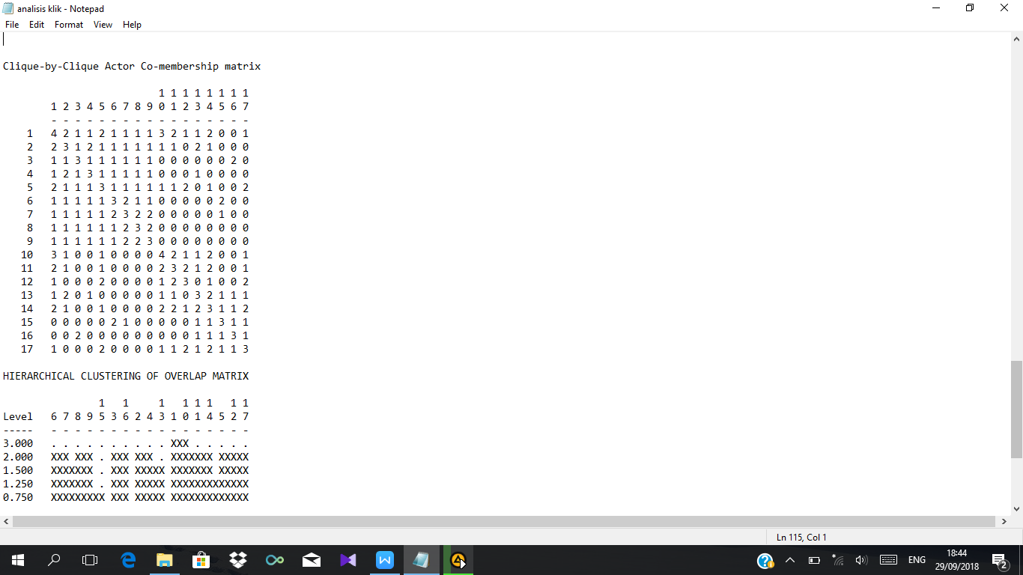
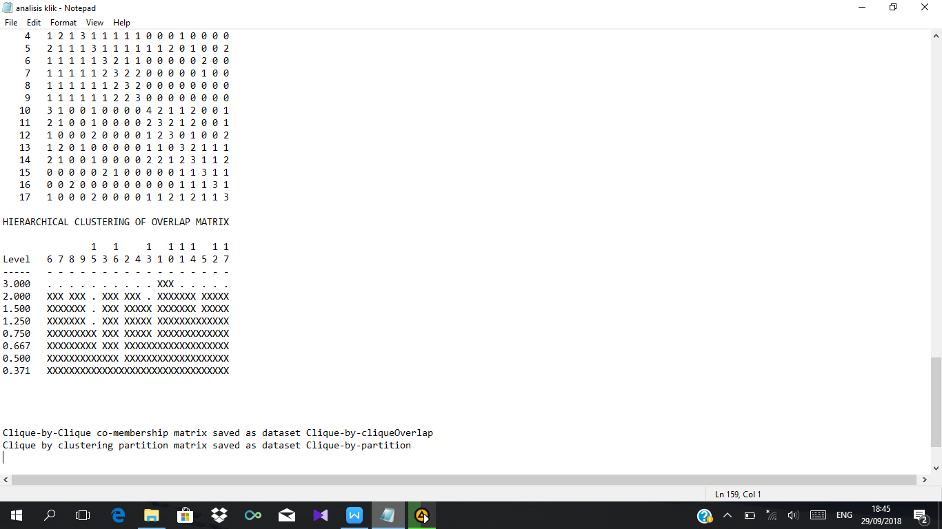
Clique-by-Clique co-membership matrix saved as dataset Clique-by-cliqueOverlap
Clique by clustering partition matrix saved as dataset Clique-by-partition

----------------------------------------
Running time: 00:00:01
Output generated: 02 Sep 18 13:12:09
UCINET 6.661 UCINET 6.661 Copyright (c) 1992-2017 Analytic Technologies

- STRUKTUR JARINGAN KOMUNIKASI (KEPADATAN (DENSITY) DAN DIAMETER)
Whole Network Measures
No. | Analisis | Hasil
1 | Avg Degree | 2,545
2 | Indeg H-Index | 4
3 | Deg Centralization | 0,286
4 | Out-Central | 0,272
5 | In-Central | 0,571
6 | Density | 0,121
7 | Components | 11
8 | Component Ratio | 0,476
9 | Connectedness | 0,418
10 | Fragmentation | 0,582
11 | Closure | 0,336
12 | Avg Distance | 2,285
13 | SD Distance | 1,155
14 | Diameter | 5
15 | Wiener Index | 441
16 | Dependency Sum | 248
17 | Breadth | 0,762
18 | Compactness | 0,238
19 | Small Worldness | 2,643
20 | Mutuals | 0,048
21 | Asymmetrics | 0,147
22 | Nulls | 0,805
23 | Arc Reciprocity | 0,393
24 | Dyad Reciprocity | 0,244
24 rows, 1 columns, 1 levels.

For symmetric matrices, Centralization is Freeman's degree centralization.
For non-symmetric matrices, Centralization is indegree centralization.

--------------------------------------
Running time: 00:00:01 seconds.
Output generated: 02 Sep 18 13:08:04
UCINET 6.661 Copyright (c) 1992-2017 Analytic Technologies

